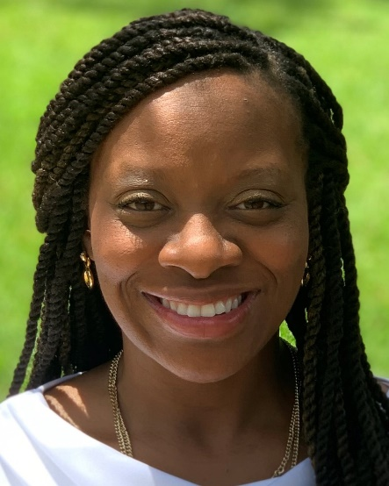

Tekla Sanders, PhD. MBA, MHSA
Adjunct

Originally from Clinton, Mississippi, Tekla Sanders received a Bachelor of Science degree in Biological Sciences from the University of Southern Mississippi, a Master of Healthcare Administration and Master of Business Administration from Texas Woman’s University and a Ph.D. in Clinical Health Sciences from the University of Mississippi.

For more than ten years, Dr. Sanders has provided strategic guidance and oversight for a range of institutional environments, including health care, education, and law enforcement, in meeting their charge to develop programs able to reduce disparities and improve compliance with appropriate standards. In health care, she has helped develop and evaluate programs focusing on topics of importance to rural, economically disadvantaged, and minority populations, as well as evaluating approaches in health and behavioral education developed to improve patient experiences of chronic illness.
Dr. Sanders' research particularly focuses on improving the relevance of data to communities and populations targeted for intervention(s), by ensuring that data collection and analysis, as well as program evaluation, include contributions from individuals and communities within the target populations so as to better define beneficial interventions and improve effectiveness.

