Attachment E – Current Technical Environment
Description | HCM | FSCM | CS
Application Version
Modules Configured / Licensed | Absence Management  Compensation  eBenefits  Enterprise Learning Management  ePay  ePerformance  Recruiting  Succession Planning  Directory Interface  Pension Administration  Payroll Interface  Global Payroll  NA Payroll  Human Resources  Time and Labor  HR Help Desk  Benefits Administration | Asset Management  Maintenance Management  CRM  IT Help Desk  Real Estate Management  Activity-Based Management  Planning and Budgeting  Funds Transfer Pricing  Risk-Weighted Capital  Global Consolidations Scorecard  Billing  Financial Analytics  Cash Management  General Ledger  CFO Portal  Internal Controls Enforcer  eBill Payment  Payables  Enterprise Service Automation  Planning and Budgeting  eSettlements  Purchasing  Expenses  Receivables  Funds Transfer Pricing  Risk Management | Academic Advisement  Contributor Relations  Campus Community  Financial Aid  Campus Self Service
PUM Version | PUM32 | PUM37 | PUM31
PeopleTools Version | 8.59.18 | 8.59.18 | 8.59.18
Oracle RDBMS | 19C | 19C | 19C
SQL Server RDBMS | N/A | N/A | N/A
Linux OS | RHEL 7.9 | RHEL 7.9 | RHEL 7.9
Windows OS | Windows server 2022 | Windows server 2022 | Windows server 2022

Primary Production Site – Allentown, PA

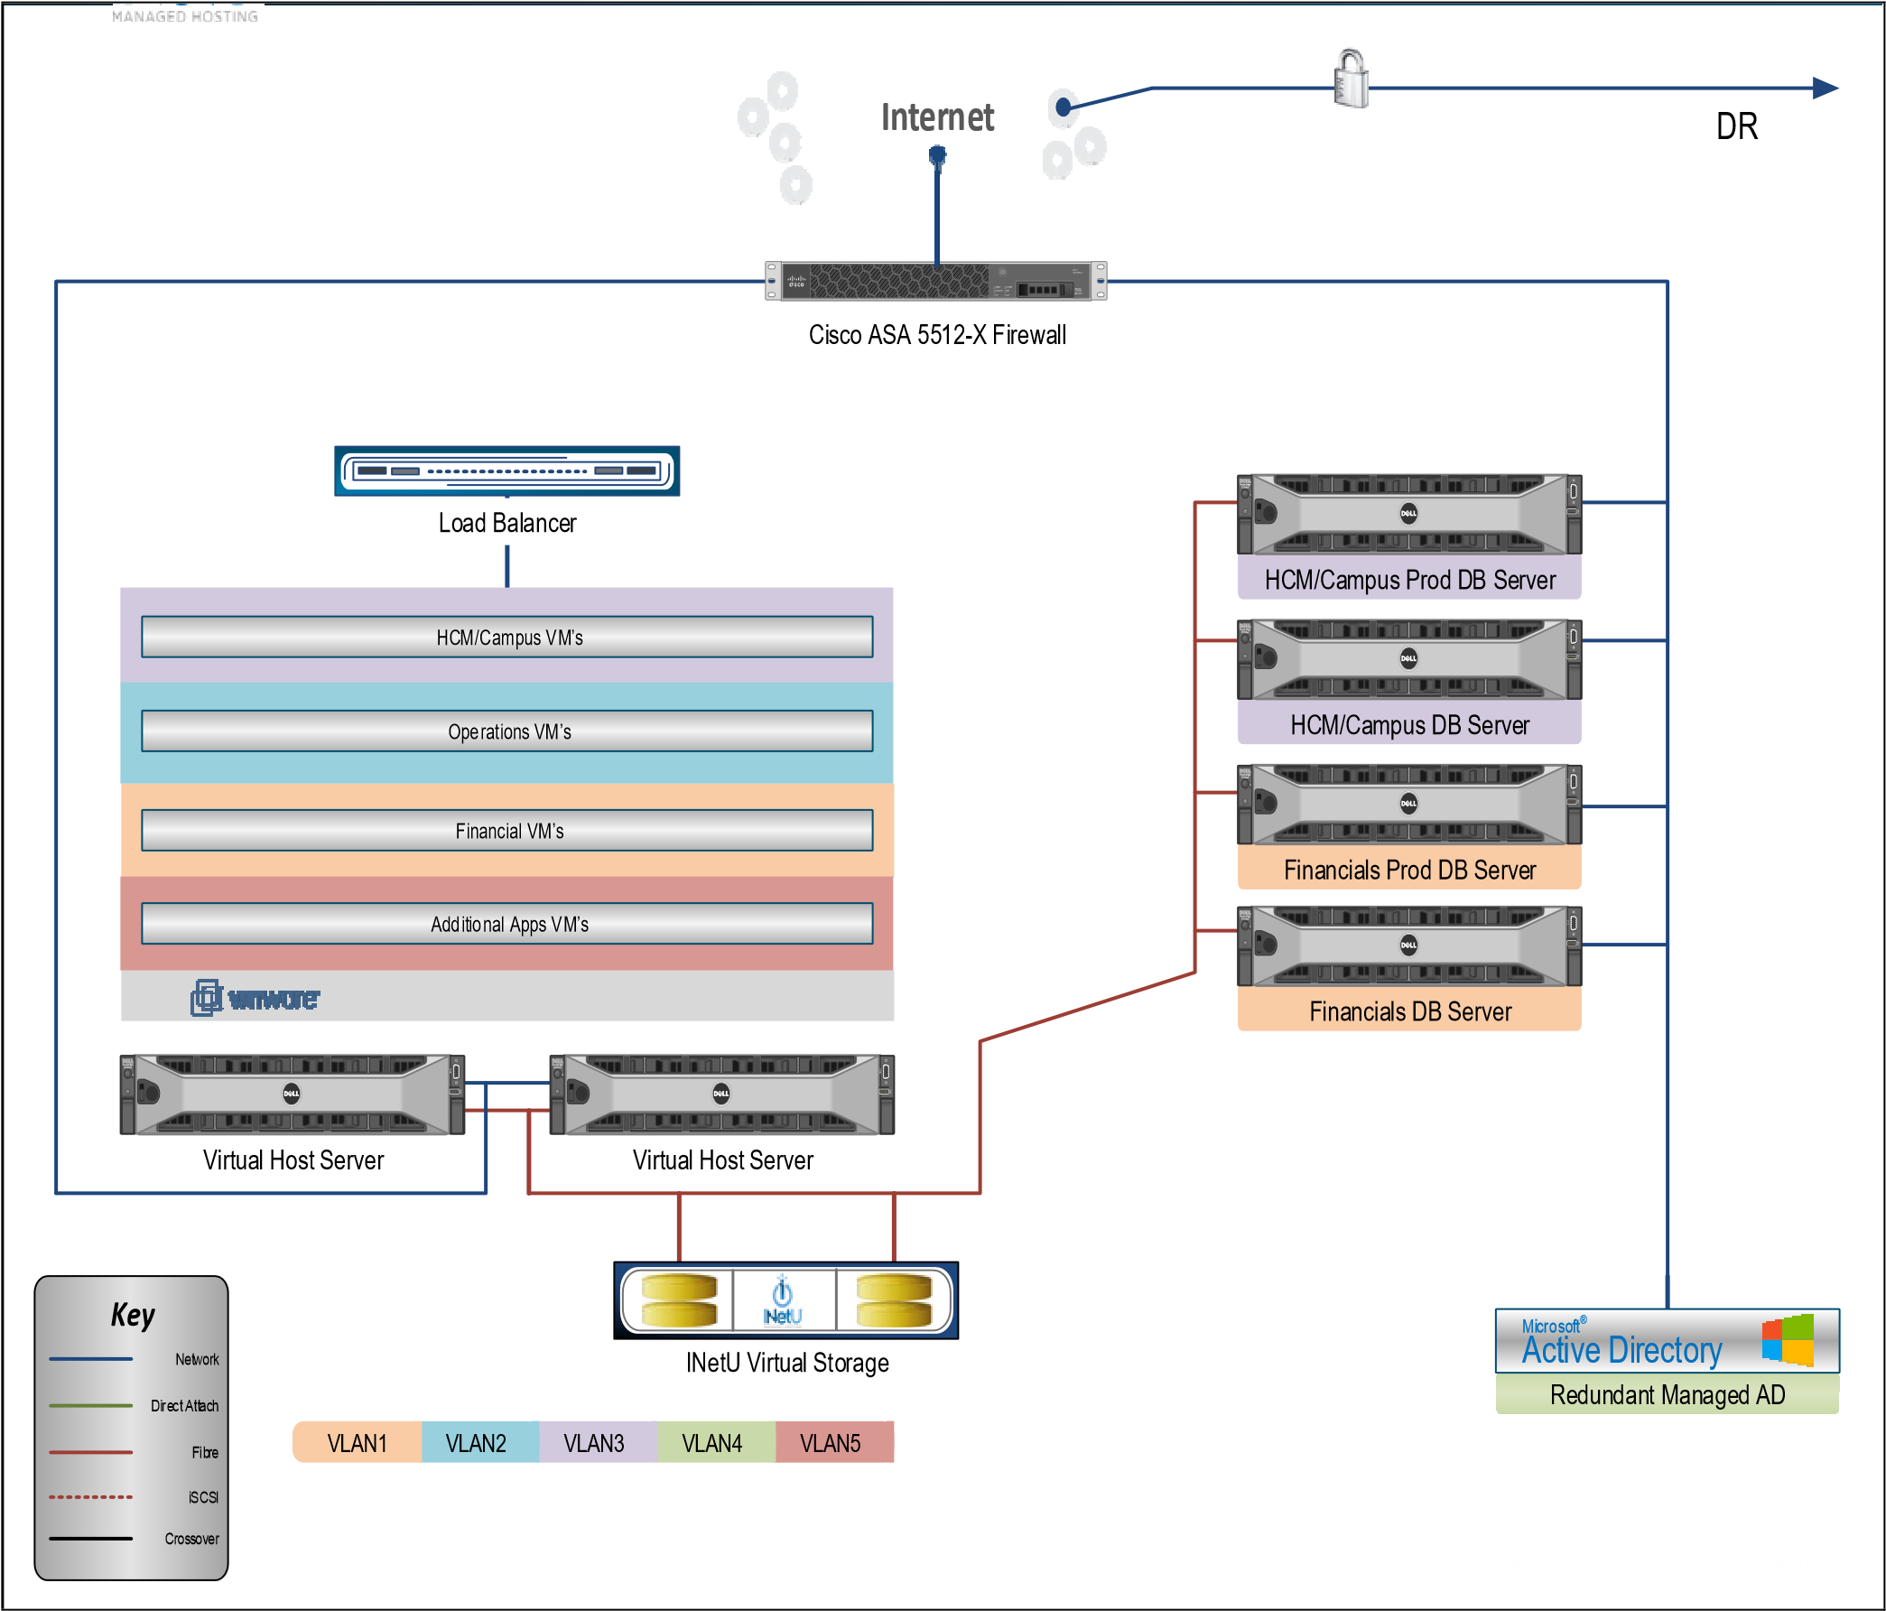

DR/Hot Site – Seattle, WA
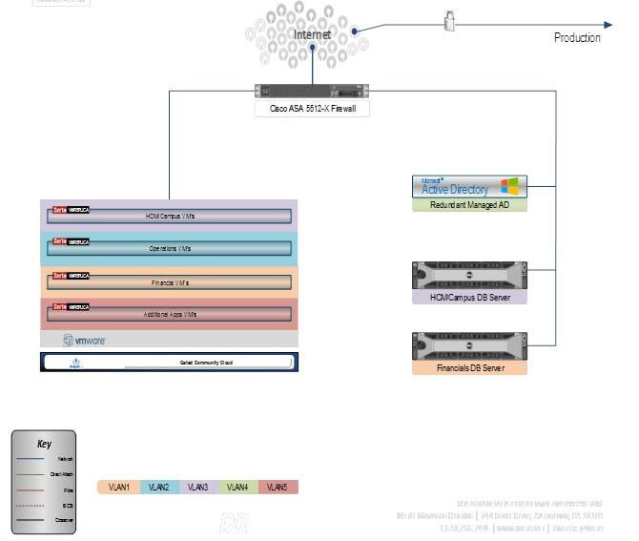

Equipment – Primary Production Site

Equipment and Services | Qty.
Managed Dedicated Cisco ASA 5512-X Security Plus Firewall w/ AnyConnect License for up to 250 VPNs  250,000 Max. connections, 1Gbps Overall Throughput, 6x Gb Ports | 1
Managed Dedicated Virtual Load Balancer 50Mbps | 1
Managed Dedicated Virtual Host Server  Dell PowerEdge R430 4-bay (3.5") Chassis, Redundant PS, Quad Port 1GbE NIC; 2 x 10C  Xeon® E5-2650 v3 2.3GHz, 25M Cache, Turbo, HT; 192GB RAM; PERC H330 Integrated  RAID Controller (RAID 1), 2x1TB SATA Hot-Pluggable HD, RAID-1; Broadcom 5719 Quad  Port 1Gb Network Interface Card, QLogic 2562 Dual Port 8Gb Optical Fiber Channel HBA, 1 Gbps - Dual Path Switch Connectivity  VMware vSphere Enterprise  ‘ | 3

VM Name/Role for HCM Software | Qty.
Dedicated Virtual Machine (HCM_CAMP_001_APP_DMO/DEV,  HCM_CAMP_001_WEB_DMO/DEV))  2 vCPU, 8GB RAM, 100GB Storage; Centralized Backups  Windows Server 2012 R2 Standard x64 | 2
Dedicated Virtual Machine (HCM_CAMP_002_APP_UAT,  HCM_CAMP_002_WEB_UAT)  2 vCPU, 8GB RAM, 100GB Storage; Centralized Backups  Red Hat Enterprise Linux 6 | 2
Dedicated Virtual Machine (HCM_CAMP_005_APP_TST,  HCM_CAMP_005_WEB_TST)  2 vCPU, 8GB RAM, 100GB Storage; Centralized Backups  Red Hat Enterprise Linux 6 | 2
Dedicated Virtual Machine (HCM_CAMP_003_APP_PROD,  HCM_CAMP_003_WEB_PROD)  2 vCPU, 8GB RAM, 100GB Storage; Centralized Backups  Red Hat Enterprise Linux 6 | 2
Dedicated Virtual Machine (HCM_CAMP_004_APP_PROD,  HCM_CAMP_004_WEB_PROD)  2 vCPU, 8GB RAM, 100GB Storage; Centralized Backups  Red Hat Enterprise Linux 6 | 2
Dedicated Virtual Machine (HCM_CAMP_005_WIN_OPS1_OPERATIONS,  HCM_CAMP_005_WIN_OPS2_OPERATIONS)  2 vCPU, 8GB RAM, 100GB Storage; Centralized Backups  Red Hat Enterprise Linux 6 | 2

VM Name/Role for Financials Software | Qty.
Dedicated Virtual Machine (FINANCIALS_001_APP_DMO/DEV,  FINANCIALS_001_WEB_DMO/DEV)  2 vCPU, 8GB RAM, 100GB Storage; Centralized Backups  Red Hat Enterprise Linux 6 | 2
Dedicated Virtual Machine (FINANCIALS_002_APP_UAT,  FINANCIALS_002_WEB_UAT)  2 vCPU, 8GB RAM, 100GB Storage; Centralized Backups  Red Hat Enterprise Linux 6 | 2
Dedicated Virtual Machine (FINANCIALS_005_APP_TST,  FINANCIALS_005_WEB_TST)  2 vCPU, 8GB RAM, 100GB Storage; Centralized Backups  Red Hat Enterprise Linux 6 | 2
Dedicated Virtual Machine (FINANCIALS_003_APP_PROD,  FINANCIALS_003_WEB_PROD)  2 vCPU, 8GB RAM, 100GB Storage; Centralized Backups  Red Hat Enterprise Linux 6 | 2
Dedicated Virtual Machine (FINANCIALS_004_APP_PROD,  FINANCIALS_004_WEB_PROD)  2 vCPU, 8GB RAM, 100GB Storage; Centralized Backups  Red Hat Enterprise Linux 6 | 2

VM Name/Role for Ancillary Applications to be Identified | Qty.
Dedicated Virtual Machine (HDIR)  4 vCPU, 4GB RAM, 400GB Storage; Centralized Backups  Windows Server 2012 R2 Standard x64 | 1
Dedicated Virtual Machine (CSGA)  2 vCPU, 8GB RAM, 100GB Storage; Centralized Backups  Windows Server 2012 R2 Standard x64 | 1
Dedicated Virtual Machine (CSG)  2 vCPU, 8GB RAM, 250GB Storage; Centralized Backups  Windows Server 2012 R2 Standard x64 | 1
Dedicated Virtual Machine (LDDW)  2 vCPU, 8GB RAM, 100GB Storage; Centralized Backups  Windows Server 2012 R2 Standard x64 | 1
Dedicated Virtual Machine (BBLN)  4 vCPU, 16GB RAM, 700GB Storage; Centralized Backups  Windows Server 2012 R2 Standard x64 | 2
Dedicated Virtual Machine (AWEB)  2 vCPU, 6GB RAM, 650GB Storage; Centralized Backups  Windows Server 2012 R2 Standard x64 | 2
Dedicated Virtual Machine (PCMF)  2 vCPU, 8GB RAM, 100GB Storage; Centralized Backups  Windows Server 2012 R2 Standard x64 | 1
Dedicated Virtual Machine (ACM)  2 vCPU, 8GB RAM, 600GB Storage; Centralized Backups  Windows Server 2012 R2 Standard x64 | 1
Dedicated Virtual Machine (LDDW_DB)  4 vCPU, 8GB RAM, 400GB Storage; Centralized Backups  Windows Server 2012 R2 Standard x64 | 1
DB Backups, 60-min Incremental, Daily Full 14 Day Retention; 1TB Quota | 1
Dedicated Virtual Machine (PCMF_DB)  2 vCPU, 8GB RAM, 600GB Storage; Centralized Backups  Windows Server 2012 R2 Standard x64 | 1
DB Backups, 60-min Incremental, Daily Full 14 Day Retention; 1TB Quota | 1
Managed Dedicated Database Server  Dell PowerEdge R730XD 12-bay 3.5" Chassis, Redundant PS, Quad Port 1GbE NIC; 1x 6C  Xeon® E5-2620 v3 2.4GHz,15M Cache; 64GB RAM; PERC H330 Integrated RAID  Controller (RAID 1), 2x1TB SATA Hot-Pluggable HD, RAID-1; Broadcom 5719 Quad Port  1Gb Network Interface Card, QLogic 2562 Dual Port 8Gb Optical Fiber Channel HBA, 1  Gbps - Dual Path Switch Connectivity, Centralized Backups  Included Software: Red Hat Enterprise Linux 6 | 4
Additional 1TB Backup LUN for Oracle DB Backups | 4
Managed Highly Available Active Directory as a Service | 1
Managed Virtual Storage:  10TB of Standard Performance Storage (All VMs and DB Servers)  Management of Backups, including Monitoring and Restorations  Backup Capacity: 1TB per server | 1
Microsoft MS-SQL 2012 Standard Edition - Per Core (2 x 4-Core) LDDW_DB Server, PCMF_DB Server | 2

Equipment – DR / Hotsite

Equipment and Services | Qty.
Managed Dedicated Cisco ASA 5512-X Security Plus Firewall w/ AnyConnect License for up to 250 VPNs  250,000 Max. connections, 1Gbps Overall Throughput, 6x Gb Ports | 1
Managed Dedicated Virtual Load Balancer  50Mbps | 1
Managed Dedicated Virtual Host Server  Dell PowerEdge R430 4-bay (3.5") Chassis, Redundant PS, Quad Port  1GbE NIC; 2 x 10C Xeon® E5-2650 v3 2.3GHz, 25M Cache, Turbo, HT;  192GB RAM; PERC H330 Integrated RAID Controller (RAID 1), 2x1TB  SATA Hot-Pluggable HD, RAID-1; Broadcom 5719 Quad Port 1Gb  Network Interface Card, QLogic 2562 Dual Port 8Gb Optical Fiber  Channel HBA, 1 Gbps - Dual Path Switch Connectivity  Included Software: VMware vSphere Enterprise | 3

VM Name/Role for HCM Software | Qty.
Dedicated Virtual Machine  (HCM_CAMP_001_APP_DMO/DEV, HCM_CAMP_001_WEB_DMO/DEV))  2 vCPU, 8GB RAM, 100GB Storage; Centralized Backups  Windows Server 2012 R2 Standard x64 | 2
Dedicated Virtual Machine (HCM_CAMP_002_APP_UAT, HCM_CAMP_002_WEB_UAT)  2 vCPU, 8GB RAM, 100GB Storage; Centralized Backups  Red Hat Enterprise Linux 6 | 2
Dedicated Virtual Machine (HCM_CAMP_005_APP_TST, HCM_CAMP_005_WEB_TST)  2 vCPU, 8GB RAM, 100GB Storage; Centralized Backups  Red Hat Enterprise Linux 6 | 2
Dedicated Virtual Machine (HCM_CAMP_003_APP_PROD, HCM_CAMP_003_WEB_PROD)  2 vCPU, 8GB RAM, 100GB Storage; Centralized Backups  Red Hat Enterprise Linux 6 | 2
Dedicated Virtual Machine (HCM_CAMP_004_APP_PROD, HCM_CAMP_004_WEB_PROD)  2 vCPU, 8GB RAM, 100GB Storage; Centralized Backups  Red Hat Enterprise Linux 6 | 2
Dedicated Virtual Machine  (HCM_CAMP_005_WIN_OPS1_OPERATIONS,  HCM_CAMP_005_WIN_OPS2_OPERATIONS)  2 vCPU, 8GB RAM, 100GB Storage; Centralized Backups  Red Hat Enterprise Linux 6 | 2

VM Name/Role for Financials Software | Qty.
Dedicated Virtual Machine  (FINANCIALS_001_APP_DMO/DEV, FINANCIALS_001_WEB_DMO/DEV)  2 vCPU, 8GB RAM, 100GB Storage; Centralized Backups  Red Hat Enterprise Linux 6 | 2
Dedicated Virtual Machine (FINANCIALS_002_APP_UAT, FINANCIALS_002_WEB_UAT)  2 vCPU, 8GB RAM, 100GB Storage; Centralized Backups  Red Hat Enterprise Linux 6 | 2
Dedicated Virtual Machine (FINANCIALS_005_APP_TST, FINANCIALS_005_WEB_TST)  2 vCPU, 8GB RAM, 100GB Storage; Centralized Backups  Red Hat Enterprise Linux 6 | 2
Dedicated Virtual Machine (FINANCIALS_003_APP_PROD, FINANCIALS_003_WEB_PROD)  2 vCPU, 8GB RAM, 100GB Storage; Centralized Backups  Red Hat Enterprise Linux 6 | 2
Dedicated Virtual Machine (FINANCIALS_004_APP_PROD, FINANCIALS_004_WEB_PROD)  2 vCPU, 8GB RAM, 100GB Storage; Centralized Backups  Red Hat Enterprise Linux 6 | 2

VM Name/Role for Ancillary Applications to be Identified | Qty.
Dedicated Virtual Machine (HDIR)  4 vCPU, 4GB RAM, 400GB Storage; Centralized Backups  Windows Server 2012 R2 Standard x64 | 1
Dedicated Virtual Machine (CSGA)  2 vCPU, 8GB RAM, 100GB Storage; Centralized Backups  Windows Server 2012 R2 Standard x64 | 1
Dedicated Virtual Machine (CSG)  2 vCPU, 8GB RAM, 250GB Storage; Centralized Backups  Windows Server 2012 R2 Standard x64 | 1
Dedicated Virtual Machine (LDDW)  2 vCPU, 8GB RAM, 100GB Storage; Centralized Backups  Windows Server 2012 R2 Standard x64 | 1
Dedicated Virtual Machine (BBLN)  4 vCPU, 16GB RAM, 700GB Storage; Centralized Backups  Windows Server 2012 R2 Standard x64 | 2
Dedicated Virtual Machine (AWEB)  2 vCPU, 6GB RAM, 650GB Storage; Centralized Backups  Windows Server 2012 R2 Standard x64 | 2
Dedicated Virtual Machine (PCMF)  2 vCPU, 8GB RAM, 100GB Storage; Centralized Backups  Windows Server 2012 R2 Standard x64 | 1
Dedicated Virtual Machine (ACM)  2 vCPU, 8GB RAM, 600GB Storage; Centralized Backups  Windows Server 2012 R2 Standard x64 | 1
Dedicated Virtual Machine (LDDW_DB)  4 vCPU, 8GB RAM, 400GB Storage; Centralized Backups  Windows Server 2012 R2 Standard x64 | 1
DB Backups, 60-min Incremental, Daily Full  14 Day Retention; 1TB Quota | 1
Dedicated Virtual Machine (PCMF_DB) | 1
2 vCPU, 8GB RAM, 600GB Storage; Centralized Backups
Windows Server 2012 R2 Standard x64
Managed Dedicated Database Server  Dell PowerEdge R730XD 12-bay 3.5" Chassis, Redundant PS, Quad Port  1GbE NIC; 1x 6C Xeon® E5-2620 v3 2.4GHz,15M Cache; 64GB RAM;  PERC H330 Integrated RAID Controller (RAID 1), 2x1TB SATA HotPluggable HD, RAID-1; Broadcom 5719 Quad Port 1Gb Network  Interface Card, QLogic 2562 Dual Port 8Gb Optical Fiber Channel HBA,  1 Gbps - Dual Path Switch Connectivity, Centralized Backups  Red Hat Enterprise Linux 6 | 4
Additional 1TB Backup LUN for Oracle DB Backups | 4
Managed Highly Available Active Directory as a Service | 1
Managed Virtual Storage:  10TB of Standard Performance Storage (All VMs and DB Servers)  Backup Capacity: 1TB per server | 1
Microsoft MS-SQL 2012 Standard Edition - Per Core (2 x 4-Core) LDDW_DB Server, PCMF_DB Server | 2

